***Stock Analysis and Prediction System using Stacked - LSTM***

| Shridharshan V.A.K  *Dept. of Computing Technologies*  *School of Computing*  *SRM Institute of Science and Technology*  Kattankulathur, Chengalpattu District,  India - 603203  sv8411@srmist.edu.in |  | DR S PADMINI  *Assistant Professor Dept. of Computing Technologies*  *School of Computing*  *SRM Institute of Science and Technology*  Kattankulathur, Chengalpattu District,  India - 603203  padminis@srmist.edu.in |
| --- | --- | --- |
| Debasish Ray  *Dept. of Computing Technologies*  *School of Computing*  *SRM Institute of Science and Technology*  Kattankulathur, Chengalpattu District,  India - 603203  dd7046@srmist.edu.in | Amal Krishna M K  *Dept. of Computing Technologies*  *School of Computing*  *SRM Institute of Science and Technology*  Kattankulathur, Chengalpattu District,  India - 603203  ak2413@srmist.edu.in | Utkarsh Raj Sinha  *Dept. of Computing Technologies*  *School of Computing*  *SRM Institute of Science and Technology*  Kattankulathur, Chengalpattu District,  India - 603203  ur5441@srmist.edu.in |

***Abstract*— The project aims to develop a robust and accurate system for forecasting stock prices, essential for investors, traders, and financial analysts. Traditional methods often struggle to capture the complex patterns and dependencies present in stock market data, leading to inaccurate predictions. The proposed system addresses this challenge by leveraging the capabilities of Stacked LSTM (Long Short-Term Memory) networks, known for their effectiveness in modeling sequential data. By stacking multiple LSTM layers, the model can learn hierarchical representations of the input data, capturing both short-term fluctuations and long-term trends in stock prices. This project involves preprocessing historical stock market data, including price, volume, and other relevant factors, to create a suitable input dataset. The Stacked LSTM architecture will then be trained on this data using techniques such as backpropagation and gradient descent to minimize prediction errors. Evaluation of the system will be conducted using various performance metrics, including accuracy, precision, recall, and F1-score. Additionally, the system's predictive capabilities will be compared against baseline models and existing approaches to assess its effectiveness in real-world scenarios. Overall, this project aims to demonstrate the potential of Stacked LSTM networks in improving the accuracy and reliability of stock prediction systems, ultimately contributing to more informed decision-making in financial markets.**

***Keywords—sustainable ecosystem, informed decision, responsible disposal, sustainable choices.***

I. INTRODUCTION

A literature survey for the "Stock Analysis and Prediction System using Stacked-LSTM" project begins with an exploration of existing research on LSTM-based stock forecasting models, including studies on network architectures, input features, and prediction performance metrics. Understanding prior work is crucial for guiding model development and evaluation.

Stock price forecasting plays a crucial role in investment decision-making. Accurate predictions enable investors, traders, and financial analysts to make informed decisions, maximizing returns and minimizing risks. Traditional forecasting methods often fall short in capturing the intricate patterns and dependencies present in stock market data, leading to suboptimal predictions. This project proposes to address these challenges by employing Stacked LSTM networks, a type of recurrent neural network (RNN) known for their ability to effectively model sequential data.

The cornerstone of this project is the utilization of Stacked-LSTM networks, an advanced variant of LSTM architecture, renowned for its ability to learn hierarchical representations of sequential data. By stacking multiple LSTM layers, the model can extract intricate patterns and dependencies from historical stock market data, thereby improving the accuracy and robustness of predictions. Stacked-LSTM networks excel in capturing long-term dependencies and recognizing subtle nuances in the data, making them well-suited for stock price forecasting tasks.

The Stock Analyzer and Prediction System consists of several key components, each contributing to its overall functionality and effectiveness. Firstly, historical stock market data, including price, volume, and other relevant factors, is collected and preprocessed to create a comprehensive input dataset. Data preprocessing involves cleaning, normalization, and feature engineering to ensure the quality and integrity of the data.

Once trained, the Stock Analyzer and Prediction System is evaluated using a range of performance metrics, including accuracy, precision, recall, and F1-score. The system's predictive capabilities are compared against baseline models and existing approaches to assess its effectiveness in real-world scenarios.

II. EXISTING SYSTEM

The LSTM architecture of this research can be seen in Fig 3. The input consists of 4 input features for 1,200 days divided into 960 training sections and 240 testing sections.Each section consists of 50 data input series to predict the next 1 data. The input is then followed by 3 LSTM layers of 96 cells each with epoch=50 and batch size=32. The output is the predicted closing price for the next day.Neural networks are a system for machine learning in which the computer acquires to accomplish numerous tasks within trial-and-error methods by analyzing training and testing models. Modular neural networks employ a number of Neural Networks for problem-solving. This paper consists of numerous routines for technical analysis of the stock market and analysis in which the indexes are calculated from price continuity used to predict future stocks. In multiple types of research, neural net-works have played a requisite role to multiple extents such as pattern recognition, monetary deposits, and many more

III. PROPOSED SYSTEM

The proposed system comprises several steps including the model train that respond accordingly to the output execution.

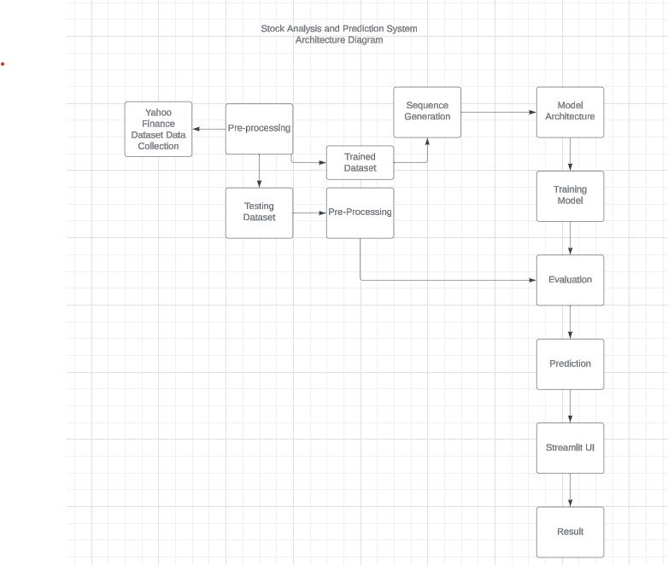

Fig. 1. Data-Flow Diagram

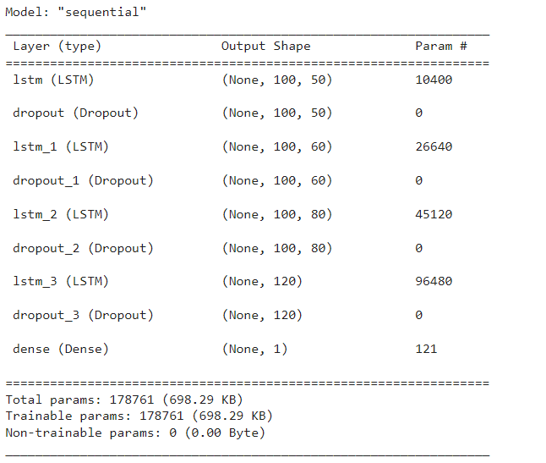

Fig. 2. Model-Architecture details

The LSTM model can be understood as an improvement and

extension of the recurrent neural network model RNN. RNN

models use the same weight matrix, and when the weight matrices are multiplied cyclically, multiple combinations of the same function tend to produce extreme nonlinear behavior, which leads to the gradient vanishing and gradient explosion problems.

As the amount of information increases, RNN models suffer

from poor long-range dependence and cannot effectively handle long sequential data. Therefore, the LSTM model came into being, which has two layer structures and three gate mechanisms, namely, cell layer, hidden layer, input gate,forgetting gate, output gate, respectively. The hidden layer stores the short-term state, the cell layer stores the long-term state, and the information between the two is interacted through three kinds of gates, and the cell structure of the LSTM model is clearly presented in Fig. 2.

*A. Dataset*

The Yahoo Finance dataset provides a wealth of financial data, including historical stock prices, trading volumes, and company fundamentals, for a diverse range of publicly traded companies. Researchers, analysts, and investors utilize this data for quantitative analysis, backtesting trading strategies, and building predictive models. With access to Yahoo Finance's APIs and downloadable datasets, users can gain insights into market trends, assess stock performance, and make informed investment decisions based on historical data.

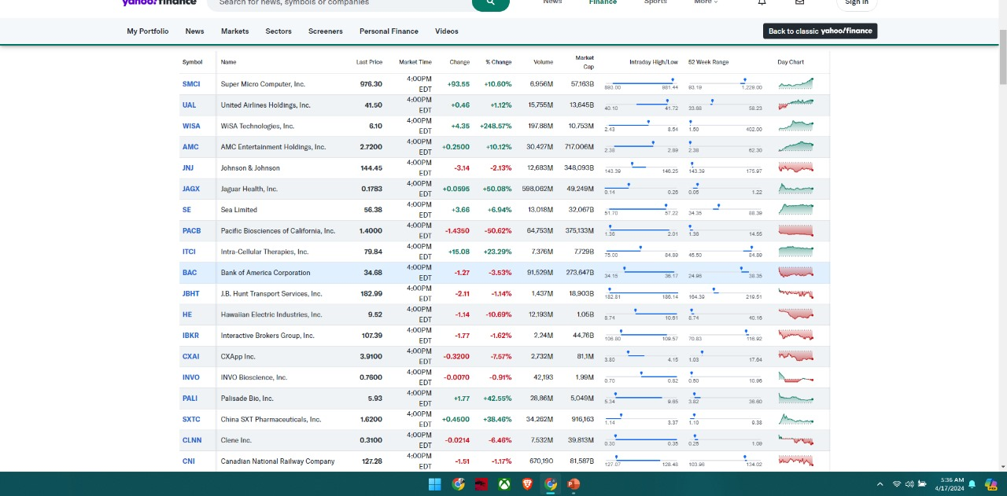

Fig. 3. Sample Dataset

*B. Code Execution*

After linking with YahooFinance Stock, we created a graph based on GOOGLE stock for model output evaluation trained on different epochs 50,75 and 100 and we evaluated the model based on different metrics- Mean Squared Error , R-Square Value and Mean Absolute Error.

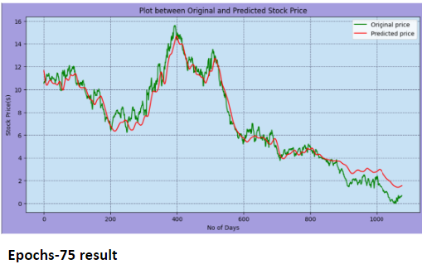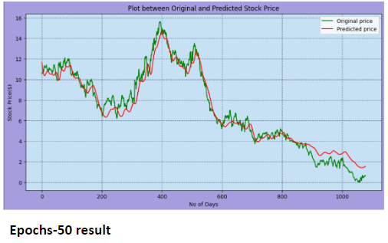

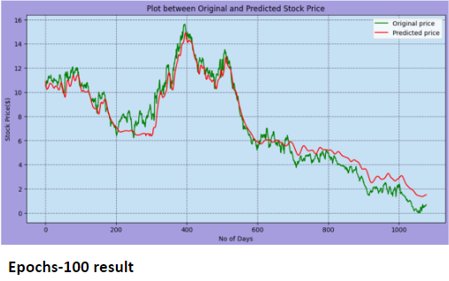

Determining which model is better for predicting Google Stock prices and better trained, let's compare the metrics of each model configuration:Evaluation:

The performance of these models can be assessed based on the MSE, MAE, and R² values:Lower MSE suggests a model that makes predictions closer to the actual data points.Lower MAE indicates a model that, on average, errors less in its predictions.Higher R² indicates a model that better explains the variance in the data from the predictors.

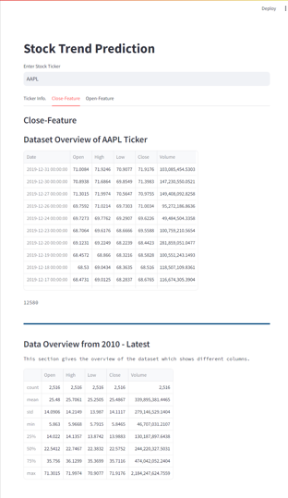

The dataset are created by Yahoo Finance website and are fetched to our project by using -

**!pip install pandas-datareader**

**import pandas_datareader.data as web**

**df = web.DataReader('AAPL', 'stooq', start, end)**

**df.head()**



IV. PROPOSED METHODOLOGY

The proposed methodology for the "Stock Prediction System Using Stacked-LSTM" project involves leveraging Stacked Long Short-Term Memory (LSTM) networks to forecast stock prices. The methodology includes collecting and preprocessing historical stock market data, designing and implementing the Stacked-LSTM architecture, training the model using backpropagation and gradient descent, optimizing hyperparameters, and evaluating the system's performance using various metrics. By harnessing the power of deep learning and Stacked-LSTM networks, this methodology aims to enhance the accuracy and reliability of stock price predictions, ultimately empowering investors, traders, and financial analysts to make more informed decisions in the financial markets.

The input gate is tasked with upgrading the cell's state with new information. The three components that make up this information addition are depicted in the figure below. Control beyond such values should be incorporated applying the sigmoid function to the state of the cell. This provides a screen for all the data from ht-1 and xt and is essentially the forget gate's predecessor. Generating a vector that includes all possible adjustments to the cell state (as determined by ht- 1 and xt). This is achieved by using the Tan(h) function, which operates on numbers between -1 and 1.

Multiplying the value of the non supervisory cell (the sigmoid gate) by the created vector as well as adding this critical information to the cell state through addition operations (the Tan(h) function). After completing these three steps, we make sure that only the most vital information is sent to the cell state. Once the previous three processes have been completed, we ensure that the cell state only includes information that is required and not irrelevant. The output gate is responsible for choosing pertinent data from the current cell state and displaying it as an output. The operation of an output gate may once more be divided into three ways: Through using the Tan(h) function to disperse the values of the cell state over a range of -1 to 1, we can produce a vector.

Constructing a cell with values of ht- 1 and to allow it to generate the values that must be collected from the vector produced over. Once more, this filter makes use of the sigmoid function. In essence, the input gate's function is to regulate the input message that can either restrict or alter the condition of the memory cell. The output gate's task is to either enable or inhibit the condition of one memory cell from impacting the actions of the numerous different components.

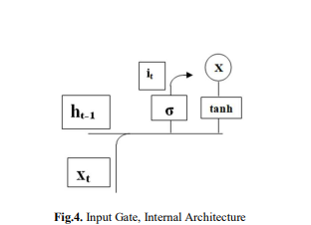

The memory cell's self-link, or forget gate, enables it to recall its prior condition. The multiplier gates enable LSTM to connect additional situational data than RNN, which addresses the issue of vanishing gradients. The input gate in a Long Short-Term Memory (LSTM) network regulates the influx of information into the cell state by determining which information from the current input and previous hidden state should be stored. It utilizes a sigmoid activation function to control the flow of information, allowing relevant data to be added to the cell state. Conversely, the output gate manages the flow of information from the cell state to the hidden state, deciding which parts of the cell state should be outputted based on the current input and previous hidden state. These gates enable LSTMs to effectively capture long-term dependencies in sequential data.

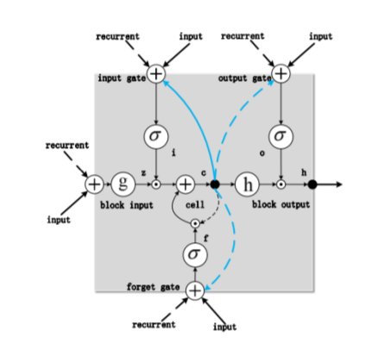

Fig: Single-cell LSTM memory cell

V. RESULT

The Stock Forecast Framework utilizing Stacked LSTM provides a comprehensive introduction to forecasted stock prices and relevant insights for decision-making. It includes forecast timeframes, specified stock tickers, and prediction horizons to elucidate prediction scope. Predicted prices for various intervals, such as opening, closing, high, and low prices, are accompanied by confidence intervals to convey volatility levels. Performance metrics like Mean Absolute Error (MAE) or Root Mean Squared Error (RMSE) offer insights into prediction accuracy. Visualizations such as line charts or candlestick charts illustrate predicted prices against actual prices, aiding interpretation. Recommendations based on forecasted prices and trends offer significant guidance for traders and investors. Transparency regarding data sources and preprocessing steps ensures clarity and reliability in presented predictions. Overall, this structured output format facilitates informed decisions in the dynamic world of stock trading and investment.

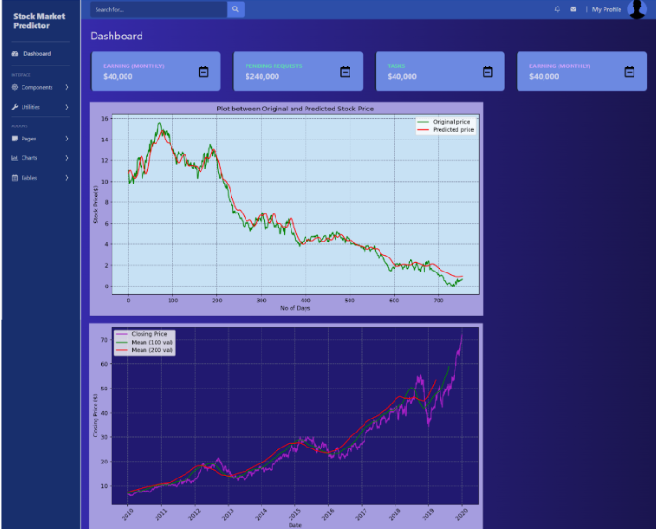

Fig: Output

In the pursuit of developing a robust Stock Prediction System using Stacked-LSTM, this project focuses on four prominent stocks: GOOG (Alphabet Inc.), AAPL (Apple Inc.), JPM (JPMorgan Chase & Co.), and MRVL (Marvell Technology Group Ltd.). These tickers represent a diverse selection of companies from various sectors, each with its unique market dynamics and influencing factors. By analyzing the historical price movements, trading volumes, and other relevant financial metrics of these stocks, the project aims to demonstrate the efficacy of Stacked-LSTM networks in accurately forecasting stock prices. Through this endeavor, insights gained from these renowned companies can contribute to enhancing the predictive capabilities of the system, facilitating informed decision-making in financial markets.

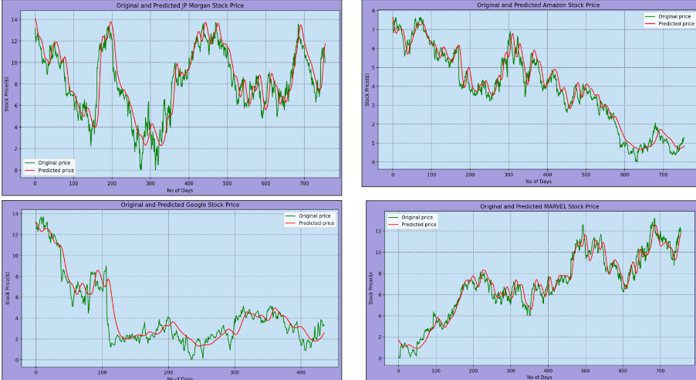

Fig: Performance and evaluation on JP Morgan, Amazon, Google and Marvel Stock

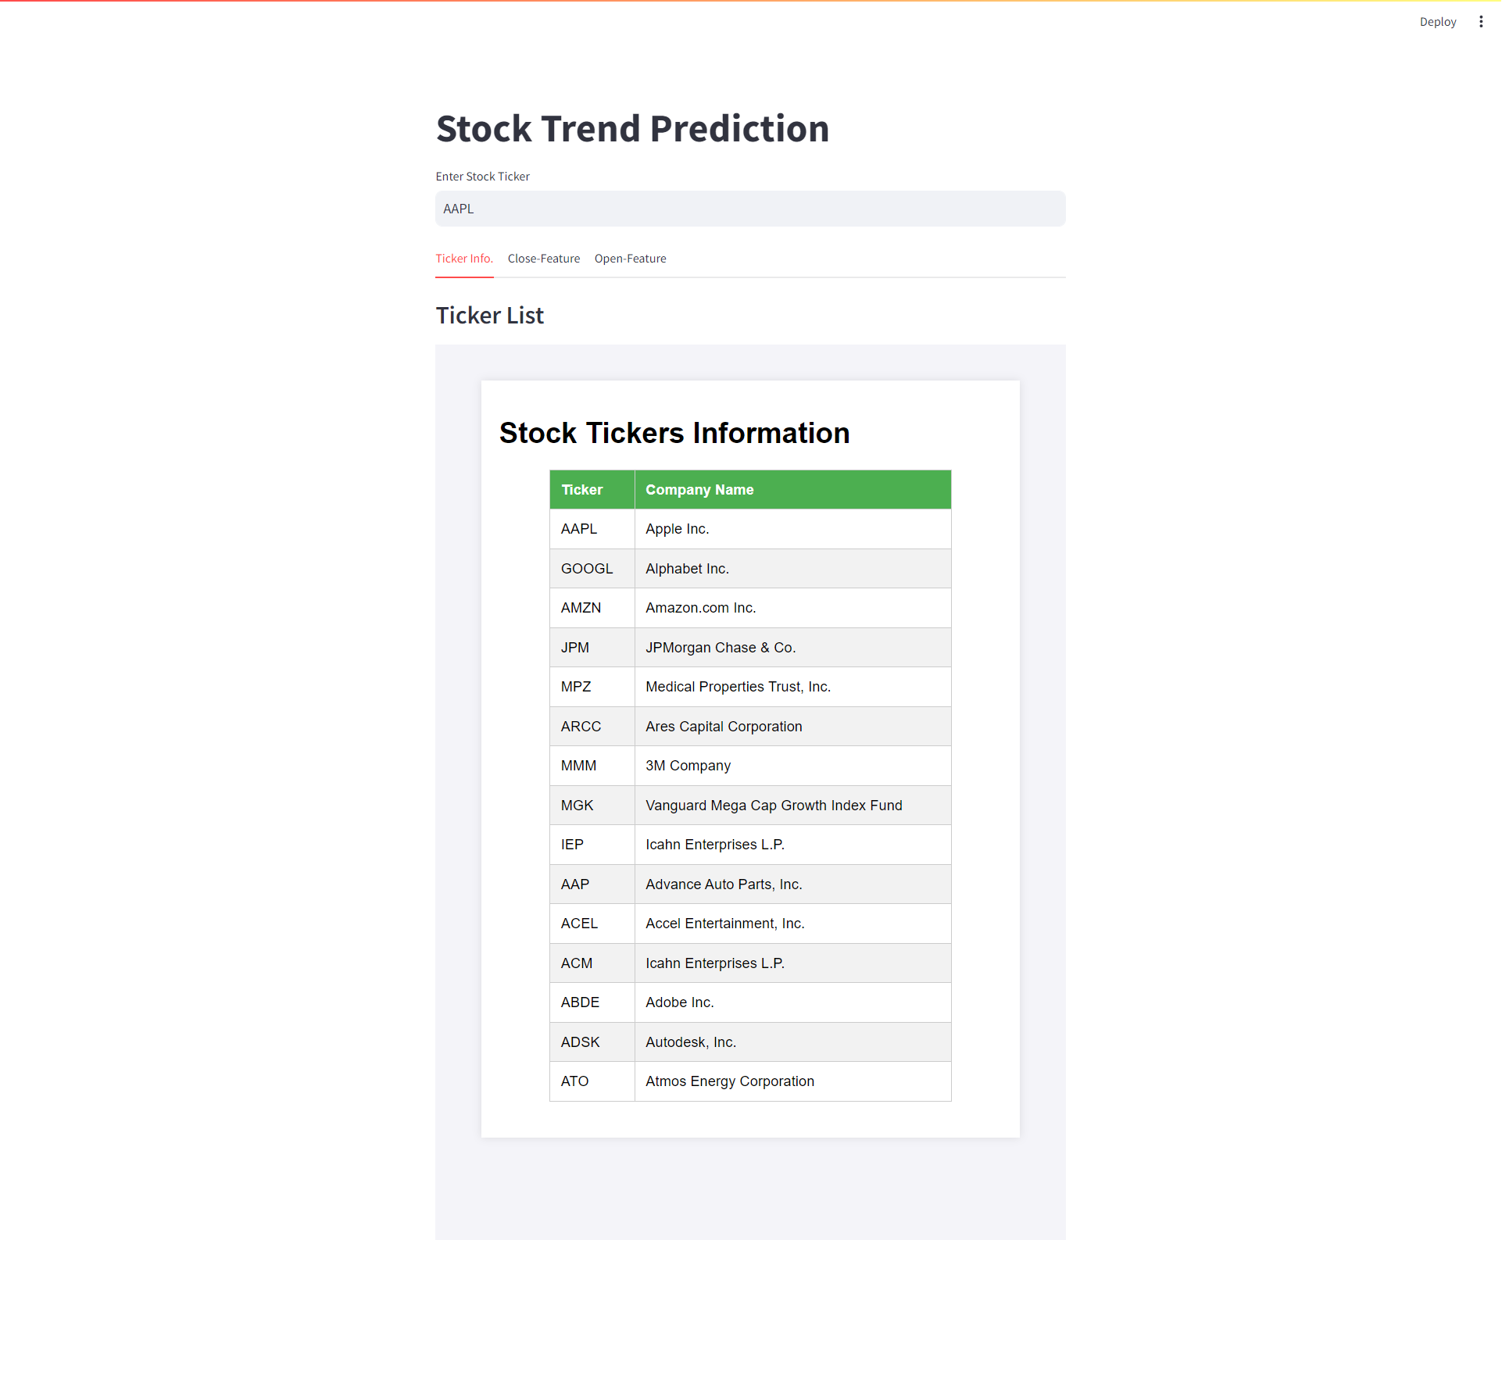

SDG 8, "Decent Work and Economic Growth," recognizes the fundamental role of economic development in achieving sustainable development. Economic growth, when inclusive and sustainable, can significantly improve the well-being of individuals and communities by creating jobs, reducing poverty, and fostering innovation. However, such growth must be coupled with measures to ensure that it benefits all members of society, including those who are traditionally marginalized or disadvantaged.

This goal emphasizes the importance of promoting full and productive employment, ensuring decent working conditions, and addressing issues such as informal employment, gender inequality in the workforce, and youth unemployment. It also calls for sustainable economic practices that prioritize environmental conservation and resource efficiency.

By pursuing the objectives outlined in SDG 8, countries can build resilient economies that provide opportunities for all while safeguarding the planet for future generations. Achieving this goal requires collaboration between governments, businesses, civil society, and other stakeholders to implement policies and practices that promote inclusive and sustainable economic growth.

Our project is implemented based on Goal-8 “Decent work and Economic Growth” where we created a portfolio for the users to have interaction with the website displaying stock-information and model predicting the value.

VI. CONCLUSION AND FUTURE SCOPE

In this study, we explored the effectiveness of stacked LSTM networks for stock price prediction. Through experimentation and analysis, we observed that stacked LSTM models exhibit promising performance in capturing the complex temporal dependencies present in financial time series data. By leveraging multiple layers of LSTM units, the model demonstrated enhanced learning capabilities, allowing it to extract more abstract and meaningful features from the input data.

Our findings suggest that stacked LSTM networks can offer valuable insights into short-term stock price movements, enabling investors and traders to make informed decisions in dynamic market environments. Moreover, the ability of these models to handle sequential data with varying time horizons makes them well-suited for forecasting tasks in the financial domain.

Future research should focus on integrating external data sources, exploring ensemble learning, attention mechanisms, transfer learning, and enhancing explainability. By addressing these areas, we can advance the application of deep learning in financial markets, empowering investors with informed decision-making tools. These developments hold the potential to revolutionize stock prediction methodologies, providing more accurate forecasts and facilitating better risk management strategies for market participants.

REFERENCES

[1] B. Wang, F. L. Zhang, “Comparison of synthetic neural community and time series version for forecasting stock prices”, Journal of Wuhan University of Technology (Information and Management Engineering), vol. 27, no. 6, pp. Sixty-nine-73, 2005.

[2] J. Lin, Y. H. Guo, “Short time period prediction of inventory expenses primarily based on neural networks”, Journal of Southwest Jiao-tong University, vol. 33, no. 3, pp. 299-304, 1998.

[3] J. H. Sun, “Long time series clustering method and its utility in inventory rate”, Diss. WuHan University, 2011.

[4] Dose, Christian, and Silvano Cincotti. "Clustering of financial time series with application to index and enhanced index tracking portfolio." Physical A: Statistical Mechanics and its Applications 355.1 (2005): 145-151.

[5] M. Arora, S. Verma, Kavita, and S. Chopra, “A systematic literature review of machine learning estimation approaches in scrum projects,” Cognitive Informatics and Soft Computing, vol. 1040, pp. 573–586, 2020.

[6] G. Yang, M. A. Jan, A. U. Rehman, M. Babar, M. M. Aimal and S. Verma, "Interoperability and Data Storage in Internet of Multimedia Things: Investigating Current Trends,Research Challenges and Future Directions," in IEEE Access, vol. 8, pp. 124382-124401, 2020, doi:10.1109/ACCESS.2020.3006036.

[7] S. Ramisetty, S. Varma, and S. Varma, “The amalgamated sharp wireless sensor networks routing and with enhanced machine learning,” Journal of Computational and Theoretical Nanoscience, vol. 16, no. 9, pp. 3766–3769, 2019.

[8] S. Kumar, R. Shanker and S. Verma, "Context Aware Dynamic Permission Model: A Retrospect of Privacy and Security in Android System," 2018 International Conference on Intelligent Circuits and Systems (ICICS), Phagwara,India, 2018, pp. 324-329, doi: 10.1109/ICICS.2018.00073.

[9] Kaur, M.; Verma, S.; Kavita. Flying Ad-Hoc Network(FANET): Challenges and Routing Protocols. J. Comput. Theor. Nanosci. 2020, 17, 2575–2581

[10] G. Alex, “Supervised collection labeling with recurrent neural networks”, Studies in Computational Intelligence, vol. 385, 2012.

[11] Cabitza, F., Locoro, A., & Ban-fi, G. (2018). Machine gaining knowledge of orthopedics: a literature review. Frontiers in Bioengineering and Biotechnology, 6, 75.

[12] Almulhim, M., Islam, N., & Zaman, N. (2019). A lightweight and secure authentication scheme for IoT based e-health applications. International Journal of Computer Science and Network Security, 19(1), 107-120.

[13] Chiu, D. Y., & Chen, P. J. (2009). Dynamically exploring the internal mechanism of the stock marketplace by using fuzzy-primarily based support vector machines with excessive dimensional input space and genetic set of rules. Expert Systems with Applications, 36(2), 1240-1248.

[14] Hamid, B., Jhanjhi, N. Z., Humayun, M., Khan, A., & Alsayat, A. (2019, December). Cyber security issues and challenges for smart cities: A survey. In 2019 13th International Conference on Mathematics, Actuarial Science, Computer Science and Statistics (MACS) (pp. 1-7).IEEE.

[15] Dai, W., Wu, J. Y., & Lu, C. J. (2012). Combining nonlinear impartial thing analy-sis and neural community for the prediction of Asian stock market indexes. Expert structures with packages, 39(4), 4444-4452.

[16] Zaman, N., Low, T. J.,& Alghamdi, T. (2014, February). Energy efficient routing protocol for wireless sensor network. In the 16th international conference on advanced communication technology (pp. 808-814). IEEE.

[17] Dash, R., & Dash, P. K. (2016). A hybrid stock buying and selling body-paintings integrating technical analysis with system getting to know techniques. The Journal of Finance And Data Science, 2(1), forty-two-57.

[18] Shah, I. A., Sial, Q., Jhanjhi, N. Z., & Gaur, L. (2023). Use Cases for Digital Twin. In Digital Twins and Healthcare:Trends, Techniques, and Challenges (pp. 102-118). IGI Global.

[19] Humayun, M., Jhanjhi, N. Z., Alruwaili, M., Amalathas, S.S., Balasubramanian, V., & Selvaraj, B. (2020). Privacy protection and energy optimization for 5G-aided industrial Internet of Things. IEEE Access, 8, 183665-183677.

[20] Guresen, E., Kayakutlu, G., & Daim, T. U. (2011). Using artificial neural community models in inventory market index prediction. Expert Systems with Applications,38(eight), 10389-10397.

[21] Jhanjhi, N. Z., Brohi, S. N., & Malik, N. A. (2019, December). Proposing a rank and wormhole attack detection framework using machine learning. In 2019 13th International Conference on Mathematics, Actuarial Science, Computer Science and Statistics (MACS) (pp. 1-9).IEEE.

[22] Ghosh, G. et al. "Secure Surveillance System Using Chaotic Image Encryption Technique." in IOP Conference Series: Materials Science and Engineering, 2020, 993(1), 012062.

[23] Shah, I. A., Jhanjhi, N. Z., Humayun, M., & Ghosh, U. (2022). Health Care Digital Revolution During COVID-19. In How COVID-19 is Accelerating the Digital Revolution (pp. 17-30). Springer, Cham.

[24] Ramisetty, Sowjanya et al. "The Amalgamative Sharp Wireless Sensor Networks Routing and with Enhanced Machine Learning" in Journal of Computational and Theoretical Nanoscience, Volume 16, Number 9, September 2019, pp. 3766-3769(4)

[25] Kaur, Manjit et al. “Flying Ad-Hoc Network: Challenges an Routing Protocols” in Journal of Computational and Theoretical Nanoscience, Volume 17, Number 6, June 2020, pp. 2575-2581(7)